**Data Structures and Algorithm**

**1. E-commerce Platform Search Function**

**Big O Notation:**

Big O notation describes the **upper bound of the time (or space)** an algorithm takes to run relative to the input size n. It helps identify **scalability** and **efficiency**.

* **O(1):** Constant time — very efficient.
* **O(log n):** Logarithmic — fast even for large data.
* **O(n):** Linear — time grows with input size.
* **O(n log n), O(n²):** Less efficient for large inputs.

**Search Case Scenarios:**

|  |  |
| --- | --- |
| **Case** | **Description** |
| **Best** | The item is found immediately (first element). |
| **Average** | The item is somewhere in the middle. |
| **Worst** | The item is at the end or not present at all. |

**Search Algorithm Scenarios :**

1. **Linear Search (Simple Lookup)**
   * Best Case: O(1) - Target is first item
   * Average Case: O(n) - Target is middle of list
   * Worst Case: O(n) - Target is last item or not present
   * Use Case: Small inventories (<100 items) or unsorted data
2. **Binary Search (Divide & Conquer)**
   * Best Case: O(1) - Target is midpoint
   * Average Case: O(log n) - Halves search space each step
   * Worst Case: O(log n) - Item at extremes or missing
   * Use Case: Large sorted inventories (>1,000 items)

**Code :**

import java.util.Arrays;  
import java.util.Comparator;  
  
class Product {  
 private int id;  
 private String name;  
 private String category;  
   
 public Product(int id, String name, String category) {  
 this.id = id;  
 this.name = name;  
 this.category = category;  
 }  
   
 public int getId() {  
 return id;  
 }  
 public String getName() {  
 return name;  
 }  
 public String getCategory() {  
 return category;  
 }  
}  
  
class SearchUtility {  
  
 public static Product linearSearch(Product[] products, int targetId) {  
 for (Product product : products) {  
 if (product.getId() == targetId) {  
 return product;  
 }  
 }  
 return null;  
 }  
  
 public static Product binarySearch(Product[] sortedProducts, int targetId) {  
 int left = 0;  
 int right = sortedProducts.length - 1;  
   
 while (left <= right) {  
 int mid = left + (right - left) / 2;  
 int midId = sortedProducts[mid].getId();  
   
 if (midId == targetId) {  
 return sortedProducts[mid];  
 } else if (midId < targetId) {  
 left = mid + 1;  
 } else {  
 right = mid - 1;  
 }  
 }  
 return null;  
 }  
}  
  
public class ECommerceSearch {  
 public static void main(String[] args) {  
  
 Product[] inventory = {  
 new Product(1001, "Wireless Earbuds", "Electronics"),  
 new Product(2002, "Office Chair", "Furniture"),  
 new Product(3003, "Running Shoes", "Footwear"),  
 new Product(4004, "Blender", "Kitchen Appliances"),  
 new Product(5005, "Novel", "Books")  
 };  
   
 //linear search  
 System.*out*.println("Testing Linear Search...");  
 Product result1 = SearchUtility.*linearSearch*(inventory, 3003);  
 *printProduct*(result1);  
   
 Product result2 = SearchUtility.*linearSearch*(inventory, 6006);  
 *printProduct*(result2); // Not found  
  
 //Binary search  
 Product[] sortedInventory = Arrays.*copyOf*(inventory, inventory.length);  
 Arrays.*sort*(sortedInventory, Comparator.*comparingInt*(Product::getId));  
   
 System.*out*.println("\nTesting Binary Search...");  
 Product result3 = SearchUtility.*binarySearch*(sortedInventory, 2002);  
 *printProduct*(result3);  
   
 Product result4 = SearchUtility.*binarySearch*(sortedInventory, 6006);  
 *printProduct*(result4);  
   
 // Performance comparison  
 System.*out*.println("\nPerformance Analysis : ");  
 *compareSearchPerformance*(sortedInventory, 5005);  
 }  
   
 private static void printProduct(Product product) {  
 if (product != null) {  
 System.*out*.println("Found product: " + product.getName() +   
 " (ID: " + product.getId() +   
 ", Category: " + product.getCategory() + ")");  
 } else {  
 System.*out*.println("Product not found");  
 }  
 }  
   
 private static void compareSearchPerformance(Product[] sortedProducts, int targetId) {  
  
 Product[] largeDataset = new Product[10000];  
 for (int i = 0; i < largeDataset.length; i++) {  
 largeDataset[i] = new Product(i + 1, "Product " + (i + 1), "Category");  
 }  
  
 // Linear search test  
 long startTime = System.*nanoTime*();  
 SearchUtility.*linearSearch*(largeDataset, targetId);  
 long linearTime = System.*nanoTime*() - startTime;  
   
 // Binary search test  
 startTime = System.*nanoTime*();  
 SearchUtility.*binarySearch*(largeDataset, targetId);  
 long binaryTime = System.*nanoTime*() - startTime;  
   
 System.*out*.println("Search performance comparison (10,000 items):");  
 System.*out*.println("- Linear search: " + linearTime + " ns");  
 System.*out*.println("- Binary search: " + binaryTime + " ns");  
 System.*out*.println("- Binary search was " + (linearTime / binaryTime) + "x faster");  
 }  
}

**Output:**

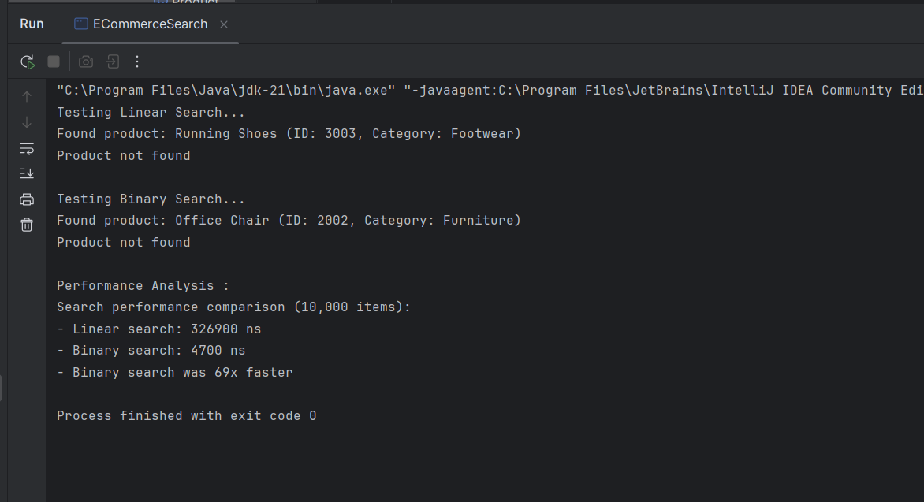

**Analysis:**

|  |  |  |  |
| --- | --- | --- | --- |
| **Algorithm** | **Time Complexity** | **Best for** | **Limitations** |
| **Linear Search** | O(n) | Small/unsorted data | Slower for large datasets |
| **Binary Search** | O(log n) | Large sorted data | Requires sorted data |

For an e-commerce platform:

1. **Binary Search** is superior for product searches because:
   * Logarithmic time complexity scales better with large inventories
   * Modern platforms have 100,000+ products (O(log n) is efficient)
   * Search operations significantly outnumber data updates
2. **Implementation Considerations**:
   * Maintain sorted product database (indexed by ID)
   * Use database indexing for efficient sorting
   * Combine with hash tables for name/category searches
   * Pre-sort new products during inventory updates

**2.Financial Forecasting:**

**Recursion:**

Recursion is when a function calls itself to solve a smaller instance of the same problem. It’s especially useful when the problem can be broken down into smaller subproblems with similar structure.

Example: Calculating compound growth, Fibonacci, factorial, etc.

**How it simplifies problems:**

1. **Natural problem decomposition:** Breaks complex problems into bite-sized chunks
2. **Elegant solutions:** Provides cleaner code for problems with self-similar patterns
3. **Mirrors real-world processes:** Perfect for modeling hierarchical structures like:
   * File systems (folders containing folders)
   * Fractal patterns in nature
   * Organizational charts
4. **Reduces complexity:** Eliminates messy loop control variables in certain scenarios

**Where it shines:**

* Tree and graph traversals
* Mathematical sequences (Fibonacci, factorials)
* Divide-and-conquer algorithms
* Backtracking problems (maze solving, puzzle games)

**Code:**

import java.util.Arrays;  
public class FinancialForecaster {  
  
 public static double predictFutureValue(double currentValue, double[] growthRates, int periods) {  
 double avgGrowth = *calculateAverageGrowth*(growthRates);  
  
 for (int i = 0; i < periods; i++) {  
 currentValue *= (1 + avgGrowth);  
 }  
   
 return currentValue;  
 }  
  
 private static double calculateAverageGrowth(double[] growthRates) {  
 double sum = 0;  
 for (double rate : growthRates) {  
 sum += rate;  
 }  
 return sum / growthRates.length;  
 }  
  
 public static void main(String[] args) {  
 double[] historicalGrowth = {0.03, 0.04, 0.025, 0.035, 0.02};  
 double currentInvestment = 10000.0;  
  
 int projectionYears = 5;  
   
 double futureValue = *predictFutureValue*(currentInvestment, historicalGrowth, projectionYears);  
  
 System.*out*.println("Financial Forecasting Tool");  
 System.*out*.println("==========================");  
 System.*out*.printf("Current Value: $%,.2f%n", currentInvestment);  
 System.*out*.println("Historical Growth Rates: " + Arrays.*toString*(historicalGrowth));  
 System.*out*.printf("Projected Value after %d years: $%,.2f%n", projectionYears, futureValue);  
 }  
}

**Output:  
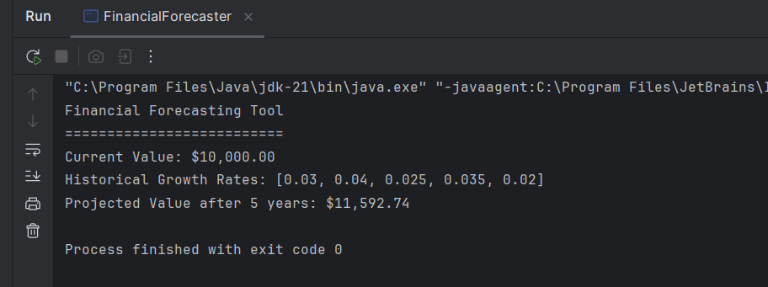  
Analysis:  
  
Time Complexity:**  
Our financial forecasting recursive algorithm exhibits **O(n) time complexity** where:

* n = number of projection periods
* Each recursive call handles one time period
* Total operations grow linearly with projection length

**The Hidden Costs:**

1. **Memory Overhead:** Each recursive call adds a new layer to the *call stack* (like stacking plates). For large n, this can cause:
   * Stack overflow errors (crashing the program)
   * Memory consumption proportional to depth (O(n) space)
2. **Function Call Overhead:** Each recursion incurs computational costs for:
   * Storing return addresses
   * Managing stack frames
   * Copying parameters  
     (Up to 10x slower than equivalent loops in some languages)
3. **Redundant Calculations:** In our example, the average growth rate gets recalculated at every step - unnecessary since it remains constant.

**Optimizing Recursive Solutions:**

**1. Memoization (Intelligent Caching):**

* **Concept:** Remember results of expensive calculations
* **How it helps:** Avoids recomputing identical sub-problems
* **Best for:** Recursive functions with overlapping sub-problems (like Fibonacci)
* **Tradeoff:** Increases memory usage but dramatically reduces time

**2. Iterative Conversion:**

* **Concept:** Re-implement recursion using loops
* **How it helps:** Eliminates stack overhead and function call costs
* **Best for:** Simple linear recursions (like our forecasting model)
* **Example:** For forecasting, a loop applying growth yearly is clearer and safer

**3. Tail Recursion Optimization:**

* **Concept:** Structure recursion so the *last* operation is the recursive call
* **How it helps:** Allows compilers to reuse stack frames
* **Caveat:** Requires language support (not available in Java)
* **Benefit:** Maintains recursive elegance with iterative efficiency

**4. Problem-Specific Mathematical Insights:**

* **Concept:** Identify closed-form mathematical solutions
* **How it helps:** For forecasting: future_value = current_value × (1 + growth)^periods
* **Impact:** Reduces O(n) complexity to O(1) - one calculation regardless of periods
* **Realization:** Sometimes recursion is a stepping stone to discover optimal solutions